TRAFFIC VOLUME ANALYSIS
Four-junction hourly flow study, November 2015 – June 2017
Prepared for: Executive stakeholders | Date: April 22, 2026

48,120  Hourly observations | 20 months  Nov 2015 – Jun 2017 | 4  Junctions monitored

Executive Summary
An hourly traffic dataset covering four junctions over twenty months was analysed to understand volume, identify patterns, and build a short-term forecasting model. The analysis produced four actionable findings for planning and operations.
- Junction 1 carries the majority of the load. It averages 45 vehicles per hour — roughly three times Junctions 2 and 3, and six times Junction 4. Any capacity or signal-timing intervention should start here.
- Traffic follows a predictable daily and weekly rhythm. Volumes peak late-morning and early-evening on weekdays, with weekend volumes roughly 25 % lower. This regularity makes short-term forecasting reliable.
- Volumes are rising year-on-year. Daily totals at Junction 1 have grown steadily across the observation window, and the model ranks calendar year as the second most important driver after the junction itself.
- A Random Forest model predicts hourly traffic with 96.5 % accuracy. Mean error is ±2.4 vehicles per hour — tight enough to support signal-timing decisions, staffing, and incident-response planning.

Finding 1 — Volume is concentrated at one junction
Over 48,120 hourly observations, vehicle counts differ sharply across junctions. The distribution is right-skewed: most hours see light traffic, but Junction 1 in particular has long, heavy tails driven by rush-hour peaks.
Junction | Avg vehicles/hr | Median | Peak hour | Share of total
Junction 1 | 45.1 | 40 | 156 | 56 %
Junction 2 | 14.3 | 13 | 48 | 18 %
Junction 3 | 13.7 | 11 | 180 | 17 %
Junction 4 | 7.3 | 7 | 36 | 9 %
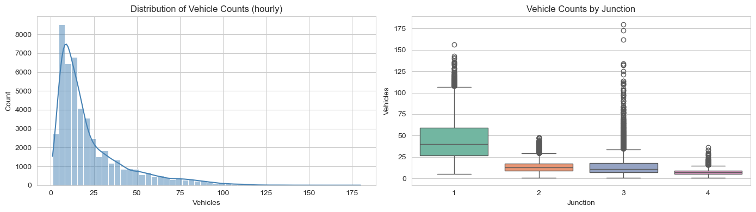
Figure 1 — Hourly vehicle distribution (left) and volume by junction (right). Junction 1's box sits far higher than the rest.

Finding 2 — Traffic follows predictable daily and weekly rhythms
Hourly and weekly patterns are consistent enough to plan around. On weekdays, volumes climb from a 4-5 a.m. trough, reach a late-morning plateau, dip modestly mid-afternoon, then peak again between 6 and 8 p.m. Saturday and Sunday averages are roughly 25 % below the Monday-to-Friday baseline. Junction 1 amplifies every pattern; Junction 4 stays flat throughout.
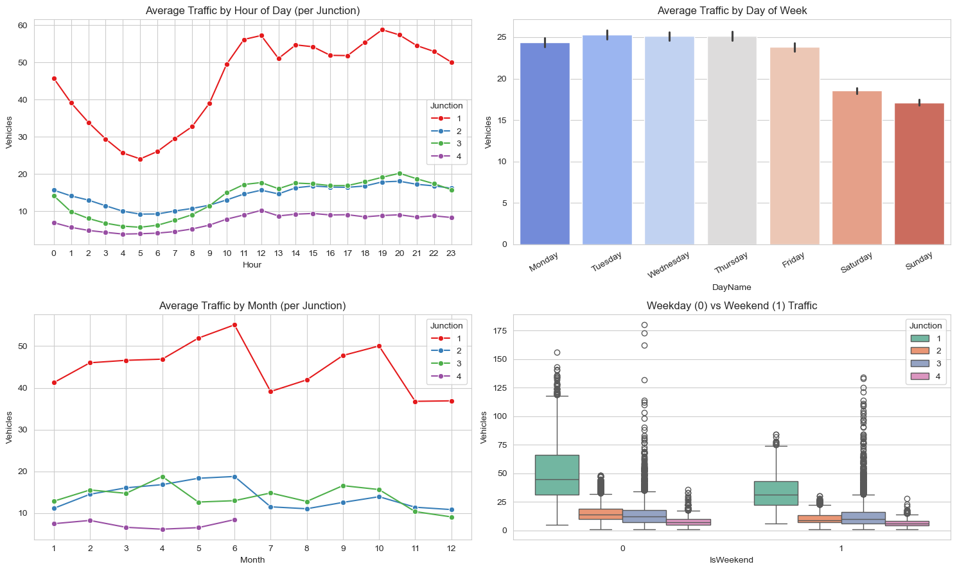
Figure 2 — Average traffic by hour of day, day of week, month, and weekend vs. weekday.

Finding 3 — Volumes are growing, particularly at Junction 1
The daily time series shows Junction 1 climbing materially between late 2015 and mid-2017, while the other three junctions remain broadly stable. The correlation heat-map confirms that the year variable is the strongest time-based predictor of volume after hour-of-day, indicating a genuine upward trend rather than seasonal noise.
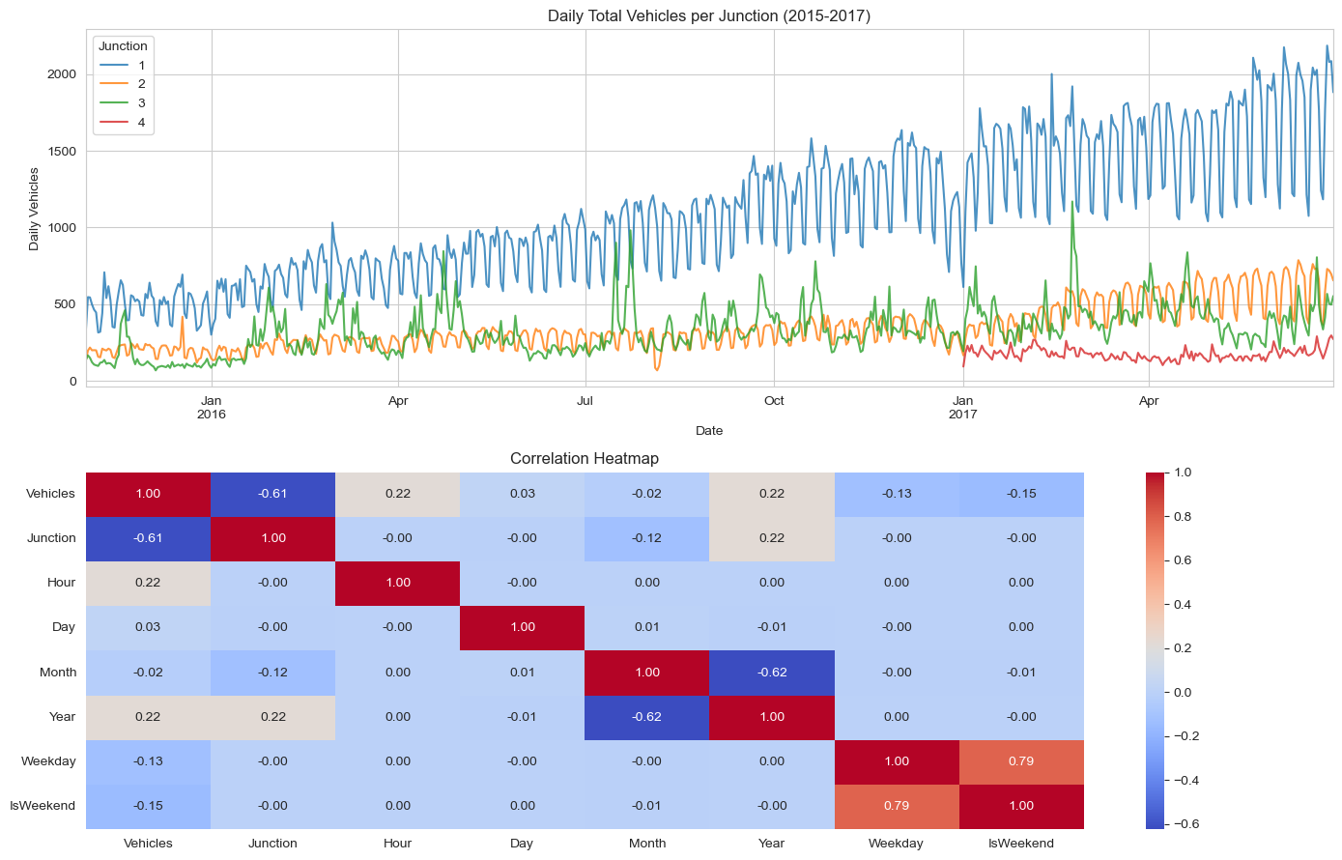
Figure 3 — Daily vehicle totals per junction (top) and correlation between features (bottom).

Finding 4 — A forecasting model is ready for operational use
Two models were fitted against a held-out 20 % test set. The Random Forest substantially outperforms a linear baseline and predicts hourly volume with a mean absolute error of about 2.4 vehicles.
Model | MAE (vehicles) | RMSE | R²
Linear Regression | 9.57 | 12.88 | 0.613
Random Forest (selected) | 2.44 | 3.85 | 0.965

Feature importance is dominated by which junction is being predicted (52 %), followed by year (16 %) and hour of day (14 %). Day-of-week and weekend flags contribute little once hour and month are known — a useful simplification for any downstream tool that needs fewer inputs.
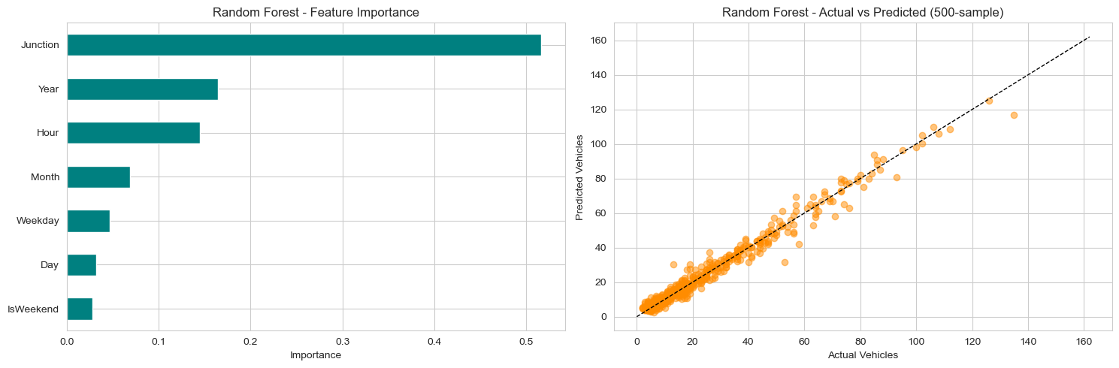
Figure 4 — Random Forest feature importance (left) and actual vs. predicted hourly volumes on a 500-point sample (right).

Recommendations
- Prioritise Junction 1 for any congestion intervention. It drives the majority of observed load and shows the steepest growth.
- Use the model for operational forecasting. A ±2.4-vehicle hourly error is suitable for signal-timing, staffing, and short-horizon planning; publish an API or scheduled report.
- Recalibrate quarterly. Because year is a top predictor, the model will drift as traffic grows; a quarterly retrain keeps accuracy stable.
- Extend the dataset where possible. Adding weather, holidays, and event calendars would likely reduce the residual error further and improve handling of unusual days.

Methodology Note
Source: hourly vehicle counts at four junctions, 1 Nov 2015 – 30 Jun 2017 (48,120 rows, no missing values, no duplicates). Features engineered from DateTime: hour, day, month, year, weekday, weekend flag. Models trained on an 80/20 random split using scikit-learn's LinearRegression and RandomForestRegressor (50 trees). Evaluation metrics: Mean Absolute Error (MAE), Root Mean Squared Error (RMSE), and R².

